Christopher Cenci Friday, September 21st, 2018

Etude One

**Object One-Silicone Hand**

The mental toil and anguish that this first object has afforded me was immense. For my final project in college, I was to create a sculpture, which included a silicone cast of my hand. Upon creation, I realized that this was not an easy feat, large amounts of money, time and struggling has went into creating this object. When the hand was finally created, I realized I had forgotten one important step, painting the object. The paint had to be mixed in with the liquid silicone, which I forgot, and now that this hand was already cast, I had to restart and purchase all the materials again. Despite all the tribulations, my project was a success, and the silicone hand being the center piece of my work is part of the reason I am at Concordia today.

The object is purely silicone, with a silicon-based paint mixed in for the color. Touching the hand gives off a very peculiar feeling, for many others, including myself. The hand looks similar to a real hand, however on touch, it gives off a cold, dead feeling, and the silicone texture quickly gives away that this is not a real hand. There is no conductive potential in this cast, as silicone rubber is the opposite, an insulator. This object is extremely resistant, it can be bent, twisted and pulled with little wear on it. 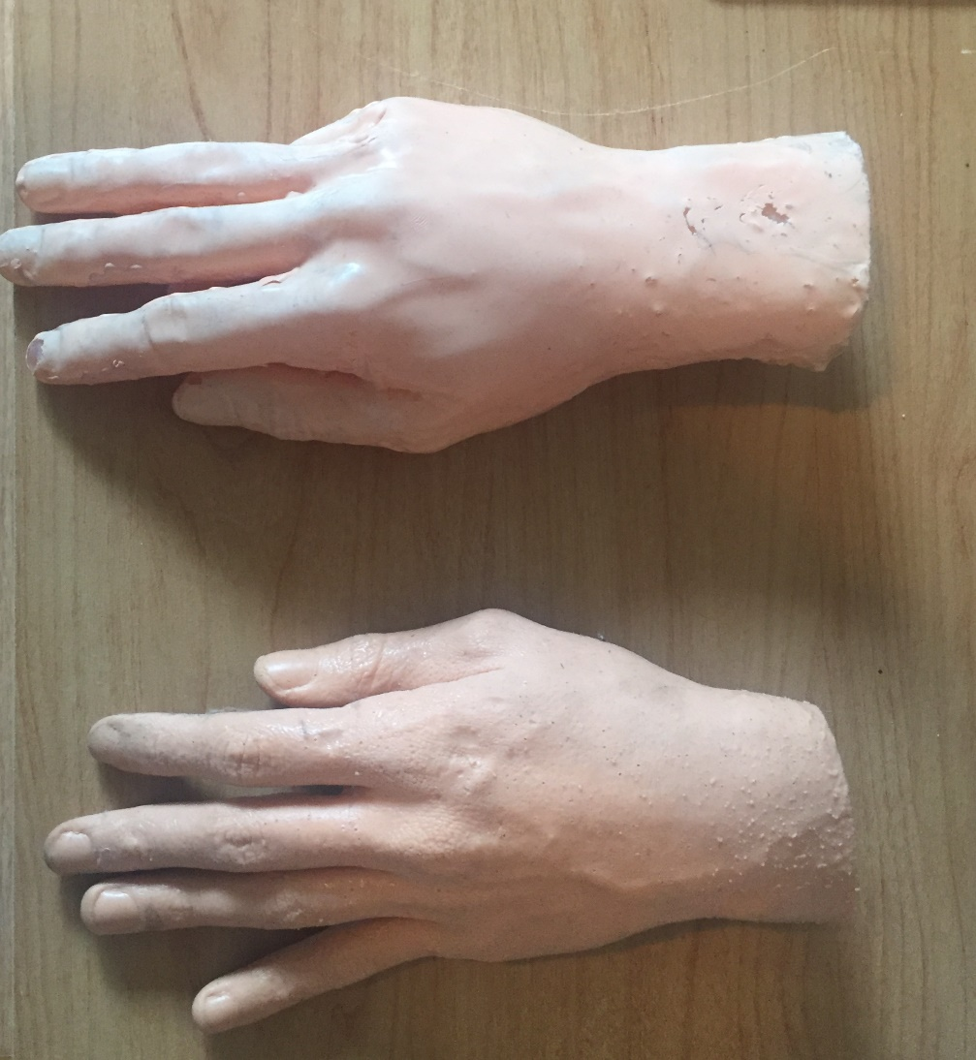

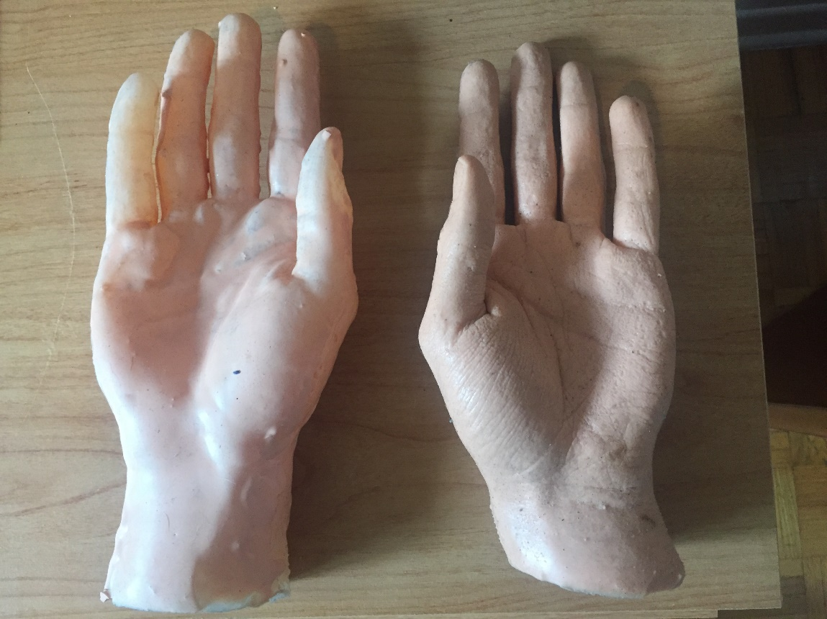

**Object Two- Zippo**

I have chosen a Zippo lighter; this Zippo has a personal connection with me. It was a gift from my father, which started my Zippo collection. It is a simple lighter, steel and grey, solid and cold to the touch, there is nothing aesthetically special about it. It is fourteen years old and still works perfectly. From him giving me this Zippo, I have bought and found eleven others, with other non-Zippo lighters added to my collection. My father also has an interest in lighters, simple tools that many people carry around, some people carry their lighters for years, and is always with them when a situation unfolds.

Although very small, this lighter feels heavier than it looks, to the touch its cold, but feels solid, like it is able to endure harsh environments. It is a simple design, there is nothing especially appealing to it, the color of steel, with tiny scratches all over it. The zippo is made out of brass, which is conductive to electricity, but not as conductive as other elements.

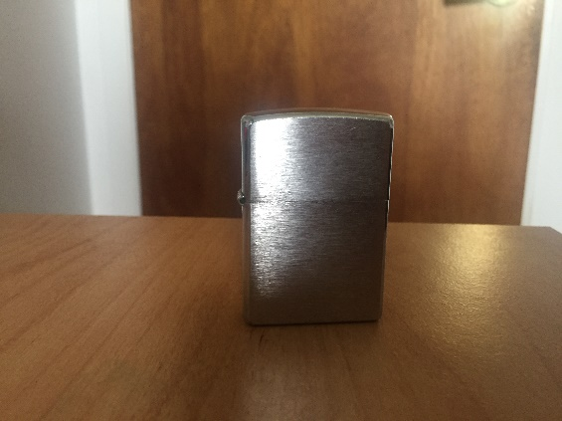

**Object Three- Hot Wheels Car**

A Hot Wheels car was chosen for an emotional and for aesthetic reasons. This car was named “Olds 442 W-30”, created in 1998 as part of the movie “Demolition Man”. A series of cars were created between 1993 to 2007, it was one of my first Hot Wheel cars given to me. Growing up, we did not have much, but every week, my father would take me to Toys ‘R’ Us and buy me one Hot Wheel, to this day I still have all of them.

There has been a change in the quality of the cars created today, in 1998, they were created with chrome plastic, a process involving chrome plating the plastic parts to prevent corrosion and degradation. The current cars are made from an alloy of zinc and aluminum. At first glance, this car looks as if it was made from metal but feels like plastic when touching it. The car is conductive as chrome plating usually contains nickel, which stands at 22% as conductive as copper. The car has a certain weight to it, which gives the impression that it is heavier than it looks, however the plastic touch of the car makes it feel flimsy.

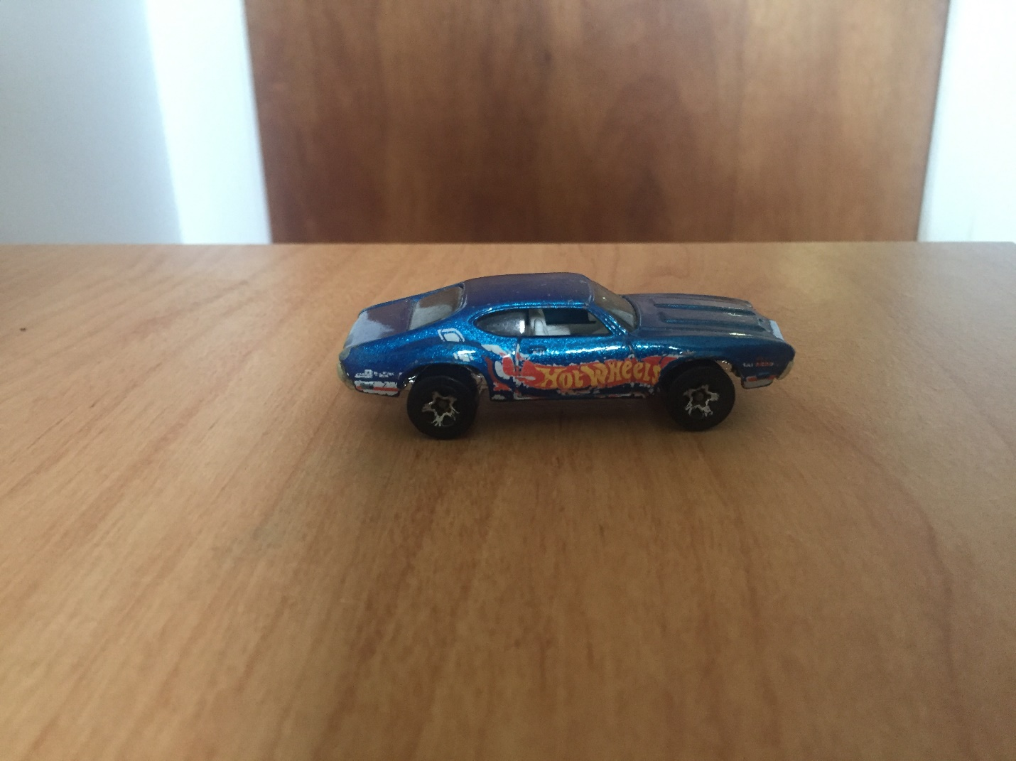

**Switch One- Misunderstood Robot**

The switch I have imagined would be a robot, with the hand as a resistor. I would imagine a scenario with a fully conductive robot with human emotions, roaming the streets. On touch, this robot sends out shocks, slightly harming the person interacting with the robot. If a person shakes the robot’s hand however, the robot lights up, becomes happy and turns its shock off.

The scenario is meant to portray that, greeting someone in a positive manner can make a person’s day. The robot always has its guard up to demonstrate how humans typically interact with people they do not know. If someone attempts to harm the robot or approach it from the back, the robot will have its guard down, but if someone greets the robot, it will let its guard down.

**Switch Two- High Fives**

The purpose of this switch is to demonstrate the complexity of certain high fives. Using the silicone hand as well as their own hand, users will attempt to invent a complex high five pattern. The switch interprets each movement (slap from the side, up or down, shake etc..) and sends a small jolt of electricity through the circuit, building up and lighting a light with each hit. The user will have to replicate the pattern three times in order for the switch to keep the lights emitted.

**Switch Three- Sensitive Hand**

The third switch involves the hand having the human sense of touch. Like a real hand, the silicone hand is able to detect what the user is doing to the hand and act accordingly. If the person were to squeeze the hand hard, it would squeeze back, if you were to hit the hand, it would curl up into a fist. The purpose of this switch is to demonstrate how an inanimate object could possess life-like qualities.

**Switch One-Storyboard**

